华北电力大学

**North China Electric Power University**

**Examples of Master Dissertation Writing**

**illustration：**

The examples cited in the specifications are only examples of the writing format of the paper, and do not represent the demonstration of the research content of the paper. **This page and the red parts of this document is to explain the requirement of format in writing and should be delete when formally writing.**



**XX学位论文**

局部多孔质气体静压轴承关键技术的研究

**Research on Key Technologies of Partial Porous Externally Pressurized Gas Bearing**

This page is the cover of paper. File this page according to your conditions. Chinese and English are both required.

**Author Name**

**20XX年X月**

国内图书分类号：×××× 学校代码：10079

国际图书分类号：×××× 密级：公开

This is the degree categories in Chinese，Font: SimSun(宋体)，18pt，middle

工学硕士学位论文

局部多孔质气体静压轴承关键技术的研究

This is the title of the paper in Chinese，Font: SimHei (黑体)，22pt，middle

This page need to be done in Chinese. Students should file the blank below according to their own conditions. SimSun(宋体), 14pt

|  |  |  |
| --- | --- | --- |
| 硕士研究生 | ： | □□□ |
| 导 师 | ： | □□□教授 |
| 申请学位 | ： | 工学硕士 |
| 学科 | ： |  |
| 专业 | ： |  |
| 所 在 学 院 | ： | 电气与电子工程学院 |
| 答 辩 日 期 | ： | 2007年6月 |
| 授予学位单位 | ： | 华北电力大学 |

Classified Index: ×××× （Times New Roman 12pt）

U.D.C: ×××× （Times New Roman 12pt）

This is the degree categories，times new roman, 18pt, middle

Dissertation for the Master Degree in Engineering

**Research on Key Technologies of Partial Porous Externally Pressurized Gas Bearing**

This is the title of the paper，times new roman，bold, 18pt，middle

Students should file the blank below according to their own conditions. times new roman, 14pt

|  |  |
| --- | --- |
| **Candidate：** | □□□ |
| **Supervisor：** | Prof.□□□ |
| **Academic Degree Applied for：** | Master of Engineering |
| **Speciality：** |  |
| **School：** | School of |
| **Date of Defence：** | June, 2007 |
| **Degree-Conferring-Institution：** | North China Electric Power University |

# 华北电力大学硕士学位论文原创性声明

本人郑重声明：此处所提交的硕士学位论文《 》，是本人在导师指导下，在华北电力大学攻读硕士学位期间独立进行研究工作所取得的成果。据本人所知，论文中除已注明部分外不包含他人已发表或撰写过的研究成果。对本文的研究工作做出重要贡献的个人和集体，均已在文中以明确方式注明。本声明的法律结果将完全由本人承担。

作者签名： 日期： 年 月 日

This page need to be filed by hand.

华北电力大学硕士学位论文使用授权书

《 》系本人在华北电力大学攻读博士学位期间在导师指导下完成的硕士学位论文。本论文的研究成果归华北电力大学所有，本论文的研究内容不得以其它单位的名义发表。本人完全了解华北电力大学关于保存、使用学位论文的规定，同意学校保留并向有关部门送交论文的复印件和电子版本，允许论文被查阅和借阅。本人授权华北电力大学，可以采用影印、缩印或其他复制手段保存论文，可以公布论文的全部或部分内容。

本学位论文属于（请在以上相应方框内打“√”）：

保密□，在 年解密后适用本授权书

不保密□

作者签名： 日期： 年 月 日

导师签名： 日期： 年 月 日

# 摘 要 （title: Font: SimHei (黑体), size: 18 pt, middle）

摘要是论文内容的高度概括，应具有独立性和自含性，即不阅读论文的全文，就能获得必要的信息。摘要应包括本论文的目的、主要研究内容、研究方法、创造性成果及其理论与实际意义。摘要中不宜使用公式、化学结构式、图表和非公知公用的符号和术语，不标注引用文献编号。避免将摘要写成目录式的内容介绍。

关键词：关键词1；关键词2；关键词3；……；关键词6

**(Content and keywords: font宋体, size 12pt or 小四, Paragraph Line Spacing: 20pt)**

# Abstract （Times New Roman 18pt, Bold, middle）

Externally pressurized gas bearing has been widely used in the field of aviation, semiconductor, weave, and measurement apparatus because of its advantage of high accuracy, little friction, low heat distortion, long life-span, and no pollution. In this thesis, based on the domestic and overseas researching……

**Keywords**: keyword 1， keyword 2，keyword 3， ……，keyword 6

**(English abstracts should be consistent with Chinese abstracts and should be accurate in grammar and vocabulary.)**

**(Content and keywords: Times New Roman 12pt, Paragraph Line Spacing: 1.25 line)**

# Contents (Times New Roman 18pt, Bold)

**Abstract (In Chinese)**........................................................................................І

**Abstract (In English)**........................................................................................ІІ

**Chapter 1 Introduction**......................................................................................1

1.1 Background, objective and significance of the subject................................1

1.2 Developmental of gas-lubricated bearing and correlated theories...............2

1.2.1 Developmental of gas-lubricated bearing.............................................2

1.2.2 Research on static characteristics of porous externally Pressurized

gas bearing........................................................................................10

……

1.3 Computational fluid dynamics and applications of correlated field...........13

……

1.5 Main research contents of this subject......................................................16

**Chapter 2 Research on permeability of** ..........................................................18

2.1 Introduction..............................................................................................18

2.2 Fractal geometry theory............................................................................18

……

2.4 Brief summary..........................................................................................24

……

**Chapter 7 Conclusions and prospects....**................................................................86

**References**.........................................................................................................88

**Papers published in the period of Ph.D. education**.........................................96

**Research Work in the period of Ph.D. education**.........................................97

**Acknowledgements**...........................................................................................98

**Resume**..............................................................................................................99

**（Times New Roman 12pt, Paragraph Line Spacing: 1.25 line, first class title need to be bolded like above）**

# Chapter 1 Introduction (Times New Roman, 18pt, Bold, placed in the middle; Paragraph Line Spacing:1.35 line, before 25pt, after 12pt)

## 1.1 Research Background (Times New Roman, 15pt, Bold; Paragraph Line Spacing: 1.35 line, before 0.5 line, after 0.5 line)

The development of advanced technologies such as national defense industry and microelectronics industry requires precision and ultra-precision instruments and equipment, and high-speed precision instruments and equipment.…… **(Times New Roman, 12pt; Paragraph Line Spacing: 1.25 line, Indent the first line by 2 characters)**

……

## 1.2 Development of Gas Lubricated Bearings

Gas bearing is a mechanical component which supports load or reduces friction by gas film.……

……

### 1.2.1 Development of Gas Lubricated Bearings (Times New Roman, 14pt, Bold; Paragraph Line Spacing: 1.35 line, before 0.5 line, after 0.5 line)

In 1828, R.R. Willis [3] published an article on pressure distribution in orifice throttle plates, which is the earliest recorded literature on gas lubrication.……

### 1.2.5 Study on Porous Gas Hydrostatic Bearing

Because of the low pressure and compressibility of gases …….

#### 1.2.5.1 Classification of Hydrostatic Bearing (Times New Roman, 12pt, Bold; Paragraph Line Spacing: 1.25 line, before 0.5 line)

The Porous Hydrostatic Bearings can be classified as……..

#### 1.2.5.2 Study on the Properties of Porous Materials

The main characteristic of the material is that it has a certain degree of....

1. Porous materials with porous properties are made up of……

# Chapter 4 Research on Bearing Static Characteristics Based on FLUENT Software

## 4.1 Introduction

Using existing commercial software to study flow field can avoid solving N-S equation program.……

……

### 4.2.3 The Setting of Boundary Conditions

In this paper, we adopt... In each direction... From the following two formulas:

 (4-1)

 (4-2)

In formula ——Average particle diameter of porous materials (m)；

——Porosity (Pore volume as a percentage of total volume)；

——Characteristic permeability or intrinsic permeability, related to the structural properties of materials (m2)。

……

### 4.3.3 Analysis of FLUENT simulation results

Figure 4-6 shows the pressure distribution in the local porous cylinder plunger and in the gas film when the radius of the local porous cylinder is different. The radii are RR = 1.5mm, 2.5mm, 3.5mm and 4.5mm, respectively. From Fig. 4-6, it can be seen that the throttling effect is very different because of the different throttling radius. Among them, the throttling effect with small radius is obvious. The pressure change corresponding to Fig. 4-6a is the most obvious, while the change of Fig. 4-6d is very small, which results in a great difference in the pressure distribution in the gas film. Thus, the bearing capacity is greatly improved with the increase of radius.

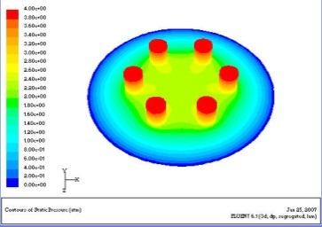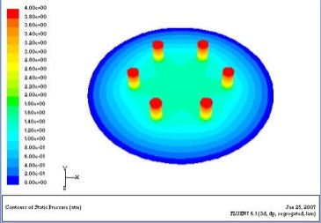

a)

b)

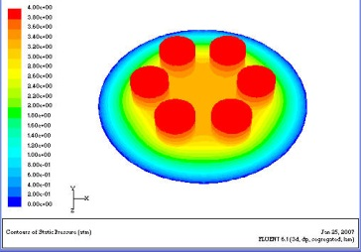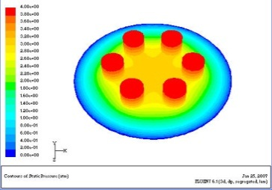

c)

d)

Fig.4-6 Pressure contour of bearing with partial porous plunger different radiuses

a) Pressure contour of bearing when**=1.5mm, b) Pressure contour of bearing when**=2.5mm

c) Pressure contour of bearing when**=3.5mm, d) Pressure contour of bearing when**=4.5mm

**(Times New Roman 10.5pt. The title of the figure should be set at the buttom of figures. Before the title, tag need to be set, example: “Fig 4-6”)**

**(You can also write in the following illustration)**

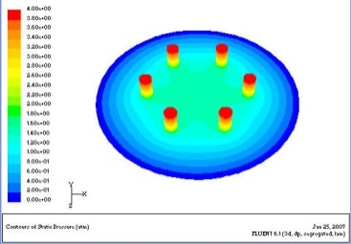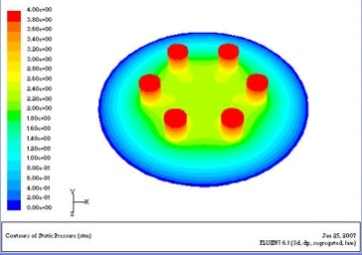

b) Pressure contour of bearing when

**=2.5mm

a) Pressure contour of bearing when

**=1.5mm

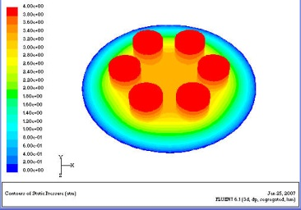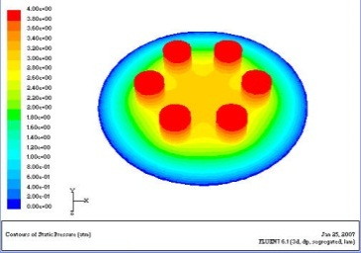

c) Pressure contour of bearing when

**=3.5mm

d) Pressure contour of bearing when

**=4.5mm

Fig.4-6 Pressure contour of bearing with partial porous plunger different radiuses

……

## 4.4 Conclusion

……

# Chapter 6 Experimental study on partial porous hydrostatic bearings

## 6.1 Introduction

In the preceding chapters, the permeability of locally porous materials is studied, respectively……

## 6.2 Porous graphite permeability test

……

The experimental data of sample No. 1 is shown in the table. 6-1。

Table 6-1 Data of measured permeability of sample 1

(Temperature: *T*=16℃ Height: *H*=5.31mm)

|  |  |  |  |  |  |
| --- | --- | --- | --- | --- | --- |
| Gas supply pressure *Ps* (MPa) | Flow measurement *M*′(m3/h) | Flow correction value *M* (m3/s) ×10-4 | Pressure difference*ΔP* (Pa) | lg*ΔP* | lg*M* |
| 0.15 | 0.009 | 0.02312 | 46900 | 4.67117 | -5.63601 |
| 0.2 | 0.021 | 0.04584 | 96900 | 4.98632 | -5.33876 |
| 0.25 | 0.039 | 0.07413 | 146900 | 5.16702 | -5.13001 |
| 0.3 | 0.097 | 0.16747 | 196900 | 5.29424 | -4.77606 |
| 0.35 | 0.136 | 0.21753 | 246900 | 5.39252 | -4.66248 |
| 0.4 | 0.171 | 0.25485 | 296900 | 5.47261 | -4.59372 |
| 0.45 | 0.202 | 0.28467 | 346900 | 5.54020 | -- |

……

**Times New Roman 10.5pt, the table need to be the standard three-lines table, title need to set on the top of table. Before the title, tag need to be set, example: “Table 6-1”**

## 6.5 Conclusion

……

# Chapter 7 Conclusion and Prospect

The conclusion of the dissertation is arranged separately as the last chapter of the main body of the dissertation.

The conclusion is a summary of the main results of the whole paper. In conclusion, we should clearly point out the creative achievements or innovative point theory (including new ideas and new viewpoints) of this research content, and point out the prospects and assumptions for further research work in this research direction in the future, and do not write the conclusion as a summary of the paper.

# References

[1]毛峡．绘画的音乐表现[A]．中国人工智能学会2001年全国学术年会论文集[C]．北京：北京邮电大学出版社,2001:739-740

[2]张和生．地质力学系统理论[D]．太原：太原理工大学,1998

[3]毛峡,丁玉宽．图像的情感特征分析及其和谐感评价[J]．电子学报,2001,29(12A): 1923-1927

[4]Quagliano L G , Nather H . Up conversion of luminescence via deep centers in high purity GaAs and GaAlAs epitaxial layers[J]. Applied Physics Letters, 1984, 45(5):555.

[5] Quagliano L G , Nather H . Up conversion of luminescence via deep centers in high purity GaAs and GaAlAs epitaxial layers[J]. Applied Physics Letters, 1984, 45(5):555.

…………

**（Font: SimSun(宋体)、Times New Roman 12pt, single spacing）**

# Papers and other achievements published during doctoral studies

1. Published academic papers

[1]×××，×××．部多孔质气体静压轴向轴承静态特性的数值求解[J]．摩擦学学报，2007，38(12): 68~72(EI收录号：071510544816)

[2]

1. Patents applied for and obtained (this need not be listed in the absence of patents)
2. Science and technology awards (not listed when no award is awarded)

**Note: If published academic papers are included in EI or SCI, please indicate the number of the papers included and the influencing factors of SCI papers. For academic papers received but not published, please indicate whether they are sources of EI or SCI.**

**SimSun(宋体)、Times New Roman，12pt，spacing line：1.25 line.**

# Scientific Research Work During Doctoral Degree Study

[1]

[2]

**(Times New Roman, 12pt; Paragraph Line Spacing: 1.25 line, Indent the first line by 2 characters)**

# Acknowledgement

I sincerely thank my mentor, Professor XXX, for his meticulous guidance. His words and deeds will benefit me all my life.

Thank you, Professor XXX, and all the teachers and students in the laboratory for their enthusiastic help and support!

Thank you for your financial support for this project.

**(Times New Roman, 12pt; Paragraph Line Spacing: 1.25 line, Indent the first line by 2 characters)**

# Author's Brief Introduction

The year * month * day comes from * year * month * day.

The students were admitted to * University * Department * specialty * and graduated from * University * year * month undergraduate course and received * bachelor's degree.

He studied in * University * College (department) * subject and obtained * master's degree.

Award winners:

Working experience:

**(Times New Roman, 12pt; Paragraph Line Spacing: 1.25 line, Indent the first line by 2 characters)**

**(The author's brief should generally include educational experience and work experience.)**